# Institute of technology of Cambodia

Department of Information and Communication Engineering



TP2-Using scanf and math library

TP: Algorithm and Programming

Professor: BOU CHANNA

Student: VEN THON

ID: e20191250

Group: I3-GIC-C

Year: 2021-2022

Contents:

TP2: Using scanf and math library

# Contents

Problem1: Write a C programing to display the following message 3

Problem2: Write a C programing to get a number from a user 4

................................................................................................................................ 4

Problem3: Write a c programing that can convert the time 5

Problem4: Write a C programing to convert time to second to a time format

including hour, minute, and second. 6

Problem5: Write a c programing that calculate some formula and display result 7

Problem1: Write a C programing to display the following message.

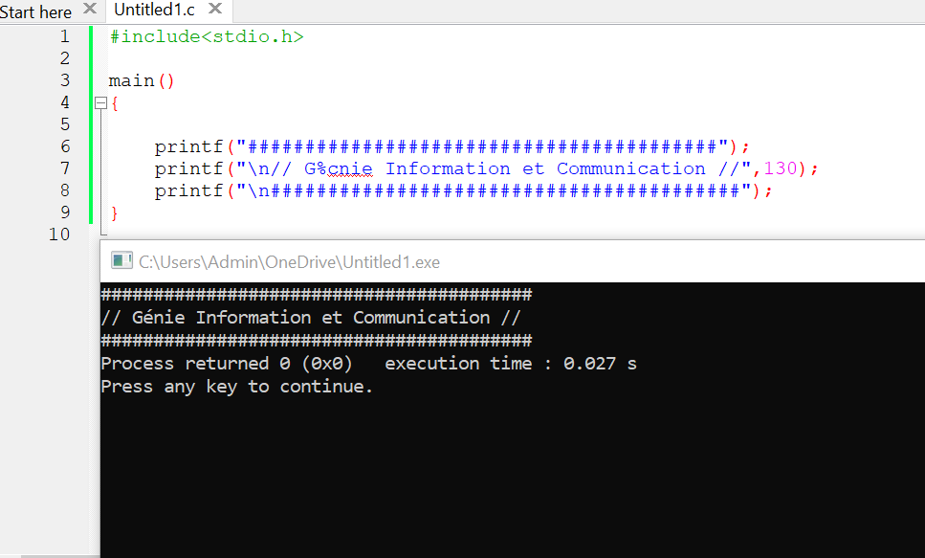

Problem2: Write a C programing to get a number from a user.

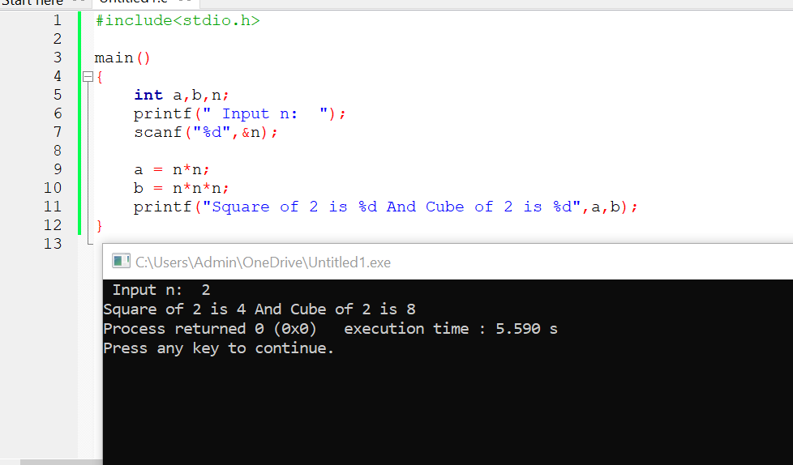

Problem3: Write a c programing that can convert the time.

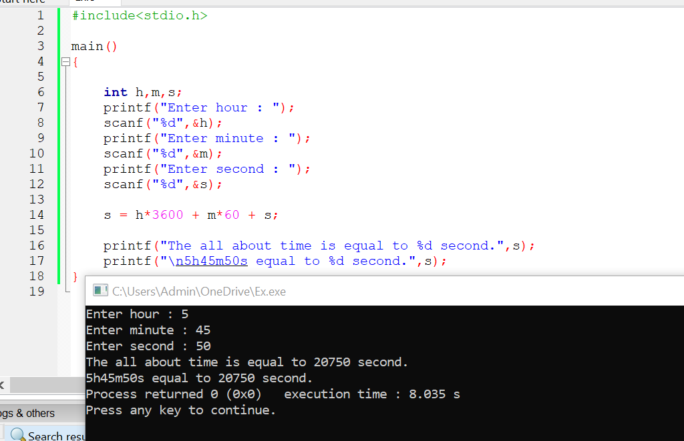

Problem4: Write a C programing to convert time to second to a time format including hour, minute, and second.

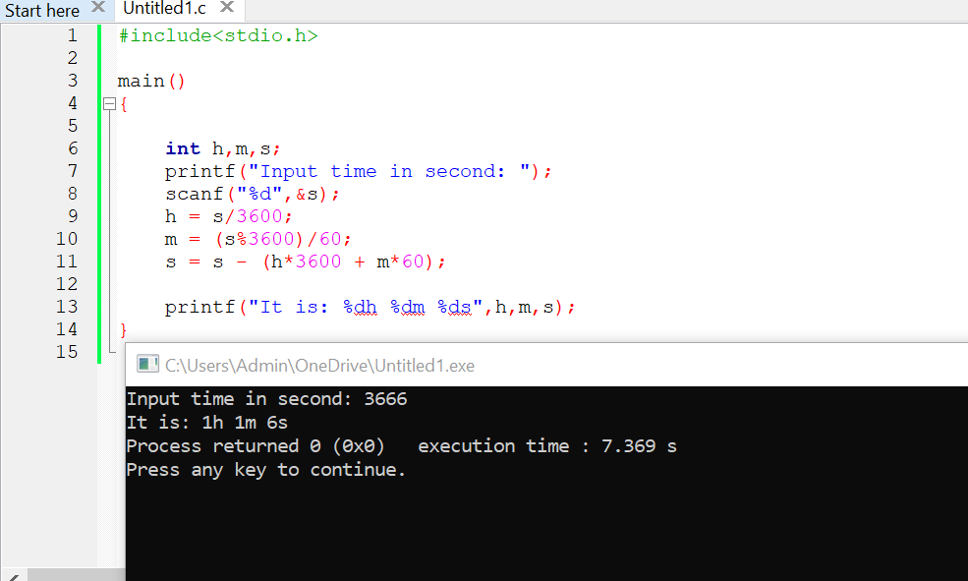

Problem5: Write a c programing that calculate some formula and display result.

